**Focus keyword**: **Tricep Exercises with Dumbbells**

**Meta Title:**– Tricep Exercises with Dumbbells | Vigoursoul

**Meta Description**: **Tricep Exercises with Dumbbells** brachii is located on the dorsal side of the upper arm. It frequently has a horseshoe shape on the back of the arm.

**Feature Image:**

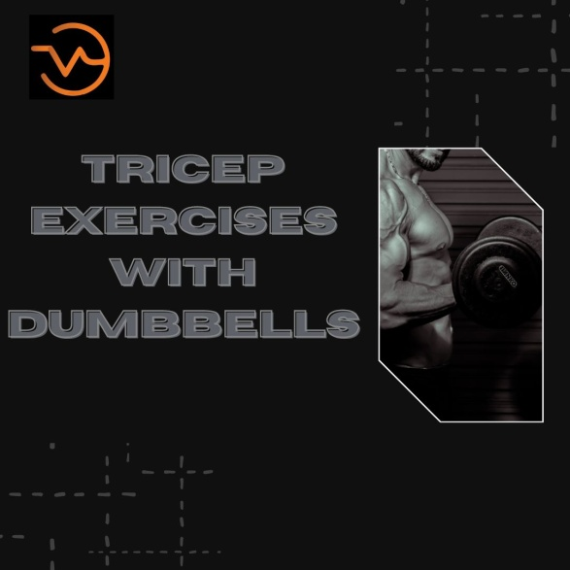

**Tricep Exercises with Dumbbells**

**Tricep Exercises with Dumbbells**, on the dorsal side of the upper arm, there is a large, dense muscle called the triceps brachii. On the back of the arm, it frequently has a horseshoe form. The triceps' main job is to extend the elbow joint. It consists of a long head, a lateral head, and a medial head (tri = three, cep = head). The tendons all originate from various places, but the three heads come together to create a single tendon distally.

**Tricep Exercises with Dumbbell**

Our triceps are divided into three parts, **Tricep Exercises with Dumbbells** which are collectively known as our "tricep heads":

* Lengthy head (the largest part)
* Head laterally (the medium-sized part)
* Lateral head (the smallest part)

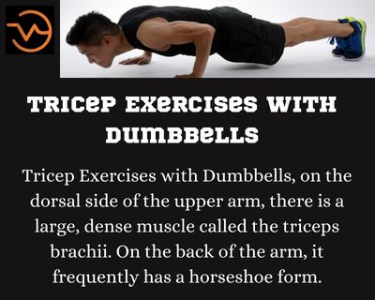

It's crucial to practice a variety of workouts that target all three parts of the triceps muscle while working out this muscle to achieve the best results in terms of overall functioning and appearance.

Among the advantages of having **Tricep Exercises with Dumbbells** that are strong and in excellent shape are:

* Improved upper body function especially during your bigger lifts
* Enhanced shoulder stability translates to a lower risk of injury.
* Stronger better sculpted arms.
* Muscular balance (biceps to triceps ratio)

**Best Triceps Exercises with Dumbbells**

While there are many **Tricep Exercises with Dumbbells** workouts that make use of various tools and devices, the following 9 exercises merely call for dumbbells. This makes them quite convenient because you can do them in the convenience of your own home gym without sacrificing your gains in triceps!

**Triceps kickback with one arm (Bench Supported)**

**Highlight of the exercise**:

Let's start with this single-arm tricep kickback exercise, a triceps classic.

This exercise has a number of modifications, which I will discuss later. However, this one is an excellent place to start. Due to the fact that it is a bench-supported exercise, more stability offered. You can isolate the weight onto each of your triceps, one at a time, thanks to this and the fact that you're utilizing one arm at a time.

**How to do it:**

Kneel on the bench and support your upper body with your non-working arm and knee while performing this exercise. Your posture should resemble that of a tabletop with a flat back. Start by holding a dumbbell in one hand and keeping your upper arm parallel to the ground.

While tightening your triceps, extend at the elbow until your arm is totally straight. When you're ready to do your next repeat, slowly return to a rough 90-degree bend at the elbow.

**Kickbacks with the triceps bent**

**Highlight of the exercise:**

Excellent for building tricep strength. This is a terrific go-to work out if you want to build up and tone your triceps. Similar to the single-arm bench-supported kickback described above, but distinct since you are utilizing your own body weight as support rather than a bench.

The bent-over tricep kickback I'm referring about in this post is performed simultaneously with both arms. However, if you enjoy unilateral exercises, you can also do this one with only one arm!

**How to do it:**

Start by standing with your feet hip-width apart and a dumbbell in each hand. When your torso is just slightly off-parallel to the ground, hinge forward at the hips. Your upper arms should be parallel to your torso with your elbows bent. Return gently to the starting position after extending at the elbow until both arms are straight.

**Risen Kickbacks (Tricep Workouts for Women)**

**Highlight of the exercise:**

Especially good for striking the long head of the triceps. Your triceps' long head is the part of the muscle that is most noticeable, especially when seen visually. Kickbacks over an inclined surface provide the long head the chance to exert the most stress across the medial and lateral heads. You'll adore this one if you're into body contouring.

**How to do it:**

Lie face down on an inclined bench with a 45-degree angle. Support your body. Your beginning posture should have your upper arm in line with your body and your elbow bent, just like in the previous kickback variations. Your upper and lower arms should be parallel to your body once you have extended your elbow. Of course, you are free to perform this workout alone. But for this one, I think the double-sided version works best.

**The Skull Crusher**

**Highlight of exercise:**

It will improve lockout strength, which is very advantageous for power and heavy lifters. Don't be deterred by the name! One of my preferred single-joint exercises to include in my triceps training regimen is this one. This exercise may help you develop both strength and hypertrophy depending on how you execute it, including the weight you use and the number of repetitions you complete.

This is a terrific go-to work out if you want to build up and tone your triceps. Similar to the single-arm bench-supported kickback described above, but distinct since you are utilizing your own body weight as support rather than a bench.

**How to do it:**

Lay flat on a bench with your feet level on the ground and a dumbbell in each hand. Starting from your shoulders, stretch your arms in a straight line upward. Dumbbells should now be lowered to either side of your head by bending only at the elbow. Push the dumbbells back up after they have reached your ears (or a point thereabout) until your arms are fully extended and your elbows are locked out.

**Tricep Exercises with Dumbbells-FAQS**

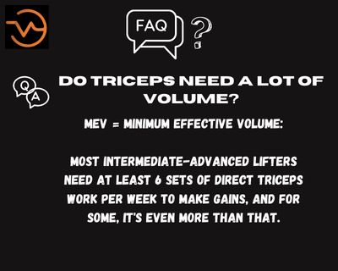

**Can you use Dumbbells to develop your triceps?**

How to extend your triceps: Hold one dumbbell with both hands in a split stance. Dumbbell should be raised above with elbows that are straight but not locked. To drop the dumbbell behind your head to a 90-degree angle or even lower, slowly bend your elbows.

**What are the top 4 triceps exercises?**

Triceps Exercise

* Bench Press with A Close Grip: 2 Warm-Up Sets of 10-15 Reps.
* Bench Press with A Close Grip: 4 Sets Of 10-15 Reps.
* 3 sets of 10-15 reps of lying triceps extensions using an EZ-curl bar.
* Dips Using a Parallel Bar: 3 Sets of 10-15 Reps

**Are three triceps workouts sufficient?**

You can probably train all three heads of your triceps with only two workouts. A pressing exercise, such as the bench press, that targets your lateral tricep heads and an overhead tricep extension, like as the lying tricep extension, that targets your long and medial tricep heads, make a great pair.

**Is it simple to strengthen triceps?**

One of the simplest exercises for making sure you're exercising the appropriate muscle is the tricep extension; you'll feel it, we promise. To perform: Place your feet shoulder-width apart as you stand. Place the weight behind your head, aiming for the area between your shoulder blades, while holding it with both hands.

**For triceps, are five exercises sufficient?**

Beginners should plan to perform four chest and triceps exercises in total throughout each session in order to achieve this. For advanced lifters, six to seven is a good target. You should normally perform more chest exercises than triceps workouts because the triceps are engaged during pressing lifts (and because they are smaller muscle groups).

**What workout most effectively activates the triceps?**

The triangle push-up is the benchmark exercise for triceps because Porcari and his team found that muscle activity peaked while subjects were performing them. According to study author Brittany Boehler, B.S., "the triangle push-ups consistently generated the greatest muscular activity in our subjects."

**Is performing triceps every day okay?**

Even if you train your triceps every day, the amount of muscular gain will not be as high as it may be. A better training frequency for the triceps is perhaps 2-3 times per week. The more you train them, the faster and bigger they'll grow, which may sound sensible!

**Conclusion**

**Tricep Exercises with Dumbbells**, adults should strength exercise for at least two days each week, according to the CDC. In order to develop stronger muscles, strength training entails the use of weights. To raise or move dumbbells into certain positions during weight training, you must overcome gravity. Strength training increases your heart rate, which assists in fat burning in addition to muscle growth.

The equal weights on either side of a small bar that fits in your hand are called dumbbells. From 2 pounds to over 100 pounds, they range in weight. It could appear simple enough to utilize them. They are moved around, picked up, lifted, and then set down again. It's not quite that easy, though. Consider seeing a certified or experienced trainer if you're new to utilizing dumbbells.